

**Midwest Healthcare**

**Management Conference**

August 17, 2023

**Gies College of Business**

**|**

**Carle Illinois College of Medicine**

**2 Venue: I Hotel & Illinois Conference Center, 1900 S 1st St, Champaign, IL 61820west Healthcare Management Conference, 2022**

# Conference website link:1 Download conference booklet:

 

**8–8:30 am | Registration & Breakfast**

### 8:30–9 am | Inauguration & Welcome

**Ujjal Kumar Mukherjee**, Gies College of Business, UIUC, Carle Illinois College of Medicine, UIUC

**Mark S. Cohen**, Dean, Carle Illinois College of Medicine, UIUC and Senior Vice President and Chief Academic Officer of Carle Health

**Mark Peecher**, Deloitte Professor of Accountancy and Executive Associate Dean of Faculty and Research

### 9–9:45 am | Keynote Address

**Challenges of Healthcare Delivery to a Diverse Population post COVID-19**.

**Sameer Vohra**, Director of Illinois Department of Public Health

**Arti Barnes**, Chief Medical Officer of Illinois Department of Public Health

**Moderator: Ron Watkins**, Gies College of Business, UIUC, Carle Illinois College of Medicine, UIUC

**9:45 –10:00 am | Break**

### 10:00–11:15 am | Managing a pandemic to reduce societal cost

**Stockpiling at the Onset of the COVID-19 Pandemic: An Empirical Analysis of National Prescription Drug Sales and Prices.**

**Anita Carson,** Questrom School of Business, Boston University

**Minje Park,** Columbia Business School, Columbia University

**Managing in-person operations in educational institutions during the pandemic: The pivotal role of testing (Opt-in/Opt-out).**

**Sebastian Souyris,** Rensselaer Polytechnic Institute

**COVID vaccine mandates and nursing homes safety.**

**Ian Larkin,** Anderson School of Management, UCLA

**Moderator: Mehmet Eren Ahsen**, Gies College of Business, UIUC, Carle Illinois College of Medicine, UIUC

**11:15 –11:30 am | Break**

**11:30 am–1:00 pm | Role of data analytics in healthcare**

**Pathways to NetZero in Healthcare: A Goal-Oriented Valuation Perspective**

**Selvaprabhu Nadarajah,** University of Illinois Chicago

**Delta Coverage: The Analytics Journey to Implement a Novel Nurse Deployment Solution**

**Pengyi Shi,** Purdue University

**Data-Driven Surgical Tray Optimization to Improve Operating Room Efficiency.**

**Sandeep Rath,** Kenan Flagler Business School at UNC

**Analysis of Compensation Contracts for Providers in Clinical Studies**

**Mili Mehrotra,** University of Illinois

**Xueze Song,** University of Illinois

**Moderator: Dmitrii Sumkin**, Gies College of Business, UIUC, Carle Illinois College of Medicine, UIUC

**1:00 –1:30 pm | Lunch**

**1:30 –2:15 pm | Competition Award Ceremony and Presentations**

**Moderator: Anton Ivanov**, Gies College of Business, UIUC, Carle Illinois College of Medicine, UIUC

## 2:15–3:30 pm | Addressing Challenges in Food and Health Safety

**Budget Allocations for Public Health Procurement**

**Iva Rashkova**, Washington University in St Louis

**Designing a Mental Health Service Recommender System: Sensing and Responding to the Personalized Support Needs and Advancing Equity in Mental Healthcare Delivery.**

**Yi Tang,** University of Minnesota - Twin Cities

**Enabling the last-mile administration of vaccines, equitably: a county-level analysis.**

**Bhupinder Juneja,** Carlson School of Management, University of Minnesota

**Moderator: Gopesh Anand**, Gies College of Business, UIUC, Carle Illinois College of Medicine, UIUC

**3:30–3:45 pm | Break**

## 3:45–5:15 pm | Role of AI and Social Financing on Managing Future Challenges of Healthcare

**Mainstreaming analytics in Illinois Medicaid**

**Andy Allison**, Illinois Department of Healthcare and Family Services

**Unveiling the Data Potential: Personalized and Compassionate care in a Diverse Post-Pandemic World**

**Roopa Foulger**, VP Digital & Innovation Development at OSF Healthcare

**Opportunities in Medicaid**

**James Parker,** Director of Office of Medicaid Innovation,University of Illinois

**Supply Chain Resiliency for Healthcare**

**Rajesh Rangaswamy,** Accenture

**Moderator: Mili Mehrotra**, Gies College of Business, UIUC, Carle Illinois College of Medicine, UIUC

## 5:15–6:30 pm | Panel Discussion on Healthcare Research of Future

**Panelists:**

### J. George Shanthikumar

Richard E. Dauch Chair of Manufacturing and Operations Management and Distinguished Professor of Management, Krannert School of Management, Purdue University, West Lafayette, IN

### Kingshuk K. Sinha

Professor, Department Chair and Elmer L. Andersen Chair in Sustainable Supply Chain, Supply Chain and Operations, Carson School of Management, University of Minnesota, Minneapolis, MN

**Ron Watkins**

### Associate Vice President, University of Illinois, SHIELD Illinois, UIUC

### Lee Kuhn

### Managing Director, Claro Healthcare

### Rodney Parker

### Kelley School of Business, Indiana University

### Ian Brooks

### School of Information Sciences, University of Illinois

### Moderator: Sridhar Seshadri

Alan J. and Joyce D. Baltz Endowed Professor, Information Systems/Operations Management/Supply Chain/Analytics Area, Gies College of Business; Health Innovation Professor, Carle Illinois College of Medicine, UIUC

## 6:30–6:45 pm | Closing Remarks

**Amy Wagoner Johnson**, Head, Department of Biomedical and Translational Sciences, Carle Illinois College of Medicine; Professor, Department of Mechanical Science and Engineering, UIUC

**Carlos Torelli**, Department Head and Professor of Business Administration and Zimmerman Faculty Fellow, Gies College of Business, UIUC

**7:00–8 pm | Dinner & Networking**

## Session 1: Managing a pandemic to reduce societal cost:

**Stockpiling at the Onset of the COVID-19 Pandemic: An Empirical Analysis of National Prescription Drug Sales and Prices.**

We examine sales of prescription drugs and find that hospitals stockpiled COVID-19 related drugs during the first two months of the pandemic. Sales decreased significantly after this period, despite an increase in COVID-19-related hospitalizations. Counter to concerns of price gouging, we find no evidence of price inflation for these drugs.

**Presenters:**

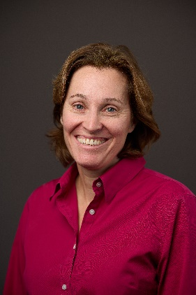

**Anita Carson,** Questrom School of Business, Boston University

Professor Carson is the Larz Anderson Professor of Management, and chair of the Operations & Technology Management department at Boston University's Questrom School of Business. She an expert on operations improvement in healthcare. Her research explores how organizations can learn from failures, and improve efficiency, quality and patient experience. A sought-after speaker, she is viewed as a leading scholar of healthcare operations management. She is a department editor at M&SOM and has won numerous awards for her research, teaching, and service.

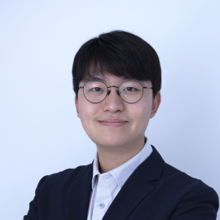

**Minje Park,** Columbia Business School

Minje Park is a postdoctoral research scholar in the Division of Decision, Risk, and Operations at Columbia Business School, Columbia University. His research investigates how organizations can be more resilient when facing supply chain disruptions such as the COVID-19 pandemic and natural disasters, with a particular focus on healthcare supply chains. He completed his PhD in Business Administration at Boston University.

**Managing in-person operations in educational institutions during the pandemic: The pivotal role of testing (Opt-in/Opt-out).**

**TBD**

**Presenter: Sebastian Souyris,** Rensselaer Polytechnic Institute

Sebastian Souyris is an Assistant Professor of Supply Chain and Analytics, holding the Dean R. Wellington ’83 (Junior) Chair at the Lally School of Management, Rensselaer Polytechnic Institute. Professor Souyris’ research addresses challenges and the means of achieving environmental and human sustainability, combining data-driven optimization, machine learning, and econometrics. He has developed impactful solutions for sustainability, healthcare, logistics, media, and sports. His work appears in Operations Research, Production and Operations Management, among other outlets. In addition, he is an INFORMS Franz Edelman Laureate, a finalist of the EURO Excellence in Practice Award, and a prizewinner of the INFORMS Revenue Management and Pricing Practice Award.

**COVID vaccine mandates and nursing homes safety.**

We study the effect of vaccination mandates for staff at nursing homes on subsequent patient health and employment, compared to a control group of homes without mandates. We find large health effects – approximately one fewer death per year per two homes. Employment effects are small, with a reduction in staff time of two minutes per day.

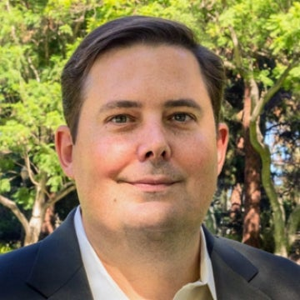

**Presenter: Ian Larkin,** Anderson School of Management, UCLA

An associate professor in the UCLA Anderson strategy group, Ian Larkin’s research is focused on compensation, incentives, employee motivation and human resources. His interest in the discipline comes compliments of his first job, with McKinsey & Company, where he spent four years as an associate and engagement manager in McKinsey’s Hong Kong and Silicon Valley offices, advising senior executives on corporate strategy in the banking and high technology industries. His primary research has ranged from the examination of corporate awards and programs that companies utilize to recognize employee performance and their potential unintended costs to decision-making influenced by various sales tactics and their respective cost outcomes in numerous industries, including technology and medicine. He is currently looking at the effects that workplace wellness programs have on employee motivation and productivity, as well as “gamification” in the workplace, which uses nonmonetary rewards to encourage improvements in employee behavior.

## Session 2: Role of data analytics in healthcare

**Pathways to NetZero in Healthcare: A Goal-Oriented Valuation Perspective**

NetZero commitments to decarbonize the healthcare sector have gained momentum among hospitals and health systems. We propose a framework to determine fiscally and socially responsible decarbonization pathways that value options to accelerate existing carbon-negative activities (e.g., preventative care), decelerate carbon-positive efforts (e.g., anesthetics), and add green investments (e.g., onsite renewables).

**Presenter: Selva Nadarajah,** University of Illinois Chicago

Selva Nadarajah is an Associate Professor of Information and Decision Sciences at the University of Illinois Chicago College of Business. He addresses challenges at the interface of operations and finance using reinforcement learning and optimization. His research focuses on the operations of commodity and energy conversion assets, their valuation and risk management, and responsible NetZero pathways. Selva has received the Energy, Natural Resources and The Environment Young Researcher Prize from INFORMS and best paper awards from the finance (Commodity and Energy Markets Association) and machine learning (NeurIPS) communities. He also serves as AI advisor at Varuna Tech.

**Delta Coverage: The Analytics Journey to Implement a Novel Nurse Deployment Solution**

We partner with IU Health to create a groundbreaking internal travel nursing program that floats nurses in 16 hospitals, addressing staffing shortages. Its success during the pandemic led to an adapted version for regular operations, combining cutting-edge AI technologies with traditional supply chain models to ensure optimal staffing.



**Presenter: Pengyi Shi,** Purdue University

Pengyi Shi is an associate professor at the Daniels School of Business, Purdue University. She received her Ph.D. degree in Industrial Engineering from Georgia Institute of Technology before joining Purdue in 2014. Her research interests include data-driven modeling and decision-making in healthcare and service operations. She has collaborated with practitioners from different healthcare organizations, including major hospitals in the US, Singapore, and China. Most recently, she is collaborating with community correctional programs to develop data-based evaluation and human-in-the-loop machine learning algorithms. Her research has won the first place of MSOM Responsible Research in OM Award in 2021, the first place of INFORMS Pierskalla Best Paper Award in 2018, and the second place of POMS CHOM Best Paper Award in 2019 and 2020.

**Data-Driven Surgical Tray Optimization to Improve Operating Room Efficiency.**

Hospitals spend several million dollars annually on instrument sterilization, tray assembly, and repurchase costs. However, less than 20-30% of reusable instruments supplied to surgery are used. We obtained actual surgical instrument usage data at UNC Rex Hospital in partnership with OpFlow, a healthcare software company. We formulate and solve a data-driven mathematical optimization model for surgical tray configuration and assignment that scales to thousands of instruments and hundreds of surgical trays. Our solution was implemented at the UNC Rex Hospital, and we estimate savings of $1.39 million per year from using the model-recommended solution at the hospital.

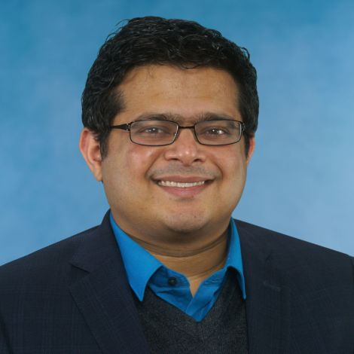

**Presenter: Sandeep Rath,** Kenan Flagler Business School at UNC

Sandeep Rath is an Assistant Professor in Operations at Kenan-Flagler Business School at the University of North Carolina at Chapel Hill. In his research, he develops practical and implementable solutions which bring together operational and clinical data to aid hospital managers in their resource planning decisions. He has partnered with healthcare technology firms and major healthcare organizations such as the Veterans Health Administration, UCLA Ronald Reagan Medical Center, and UNC Healthcare. Prior to joining UNC he received his PhD in Management from UCLA Anderson School of Management.

**Analysis of Compensation Contracts for Providers in Clinical Studies**

Participant retention is a significant challenge faced by clinical studies. In this work, we consider how the sponsor of a clinical study can motivate investigators and coordinators to improve participant retention for the study. We identify three different clinical study settings observed in practice and derive the optimal compensation contracts.

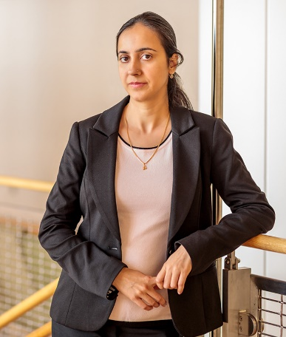

**Presenters: Mili Mehrotra,** University of Illinois

Mili Mehrotra is an Associate Professor of Business Administration in the Gies College of Business at the University of Illinois Urbana-Champaign. She received her Ph.D. in Operations Management in 2010 from the University of Texas at Dallas. Her research lies in the domain of socially-responsible supply chains and operations management. In particular, she is interested in developing and analyzing incentive schemes, and studying coordination and optimization issues that arise in practice due to the actions taken by a wide variety of stakeholders to achieve broader social objectives. She is also interested in using discrete models for analyzing problems in service operations, production planning, and logistics. Her papers have been accepted for publication in Management Science, Manufacturing and Service Operations Management, Operations Research, and Production & Operations Management. She currently serves as an Associate Editor for Manufacturing and Service Operations Management, Production & Operations Management, and Naval Research Logistics.

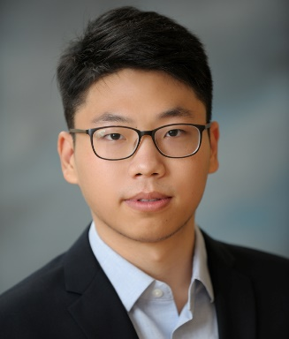

**Xueze Song,** University of Illinois

Xueze Song is a fourth-year PhD student in Operations Management at the University of Illinois at Urbana-Champaign. His research is dedicated to streamlining the delivery of innovative healthcare solutions through the optimization of the research and development process, and the integration of novel decision-making strategies. His dissertation focuses on investigating mechanisms to enhance participant retention in clinical studies, and examining their impact on reducing the risk of premature study termination. Xueze's anticipated graduation is in May 2024.

## Session 3: Addressing Challenges in Food and Health Safety

**Budget Allocations for Public Health Procurement**

Although medicine procurement decisions are seemingly complex and impact public health, published guidelines to assist donors and grant recipients with ordering are lacking. We formulate a budget allocation problem supported by an empirical analysis of Global Fund-related activities and provide a well-performing, theoretically grounded index-based heuristic for the problem.



**Presenter: Iva Rashkova**, Washington University in St Louis

Iva Rashkova is an Assistant Professor of Supply Chain, Operations and Technology at the Olin Business School, Washington University. Her research interests in sustainability and OM-Marketing interface include topics in product line design, food safety, global health and pharmaceutical supply chains. Iva has collaborated with various organizations such as the Global Fund to Fight AIDS, Tuberculosis and Malaria and Express Scripts. Iva holds a PhD in Management Science and Operations from London Business School in the United Kingdom.

**Designing a Mental Health Service Recommender System: Sensing and Responding to the Personalized Support Needs and Advancing Equity in Mental Healthcare Delivery.**

There is a huge gap between the supply and demand of mental health services. One primary reason for such gap is the lack of awareness of available mental healthcare resources. In this study, we propose a novel AI-powered mental health service recommender system delivered through a chatbot that would sense and respond to mental health mobile app users’ personalized support needs.



**Presenter: Yi Tang,** University of Minnesota - Twin Cities

Yi Tang is a PhD candidate in the Supply Chain & Operations Department at the University of Minnesota – Twin Cities. His dissertation research examines the application of mobile health technology (e.g., mobile apps, telehealth) in mental healthcare delivery with a focus on identifying mechanisms that explain the inequities associated with population socio-demographics (e.g., gender, sexual orientation, and race-ethnicity) in mental healthcare supply chain and enhance its equity and inclusiveness via innovative technology. Yi is the recipient of several research grants and awards including University of Minnesota Leadership in Equity, Inclusion and Diversity Fellowship, Cisco Research Grant, and the finalist of 2023 POMS College of Service Operations Management Best Student Paper.

**Enabling the last-mile administration of vaccines, equitably: a county-level analysis.**

Vaccine coverage can minimize the impact of the pandemic. However, there is a wide spatial disparity in vaccine coverage. While the significance of vaccine hesitancy and associated socio-economic factors are well-acknowledged, the factors related to vaccine delivery and administration from a supply-chain efficacy perspective are poorly understood. We analyze the effect of the enablers of the last mile of vaccine supply chains along 3-dimensions: logistical connectivity, delivery infrastructure, and informational connectivity. Our results suggest that all three dimensions of the last-mile delivery and administration of vaccines improve vaccine coverage. Further, we demonstrate that improving enablers of the last mile of the vaccine supply chain is more beneficial for locations with relatively higher prevalence of socio-economic and demographic risk factors.

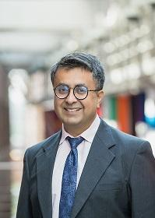

**Presenter: Bhupinder Juneja,** Carlson School of Management, University of Minnesota

Bhupinder (Bhupi) is a Senior Lecturer of Supply Chain and Operations at the Carlson School of Management. He received his PhD in Bioinformatics and Computational Biology from UMN Twin Cities, MN. His dissertation is Socio-Economic and Clinical Drivers of COVID-19 Mortality: An Empirical Analysis of the Supply-side and Demand-side Moderators. At Carlson School, Bhupi was awarded 2023 Undergraduate Instructor of the Year. He teaches Business Statistics using R and coteaches Global Operations Capstone. Additionally, he has 17 years of industry experience including 10 years as product data scientist with IBM SPSS ,7 years as Business Systems Analyst, Software Developer.

## Session 4: Role of AI and Social Financing on Managing Future Challenges of Healthcare

**Mainstreaming analytics in Illinois Medicaid**

Illinois Medicaid provides vital services for 3+ million people each year at a cost of ~$25 billion. Data accumulated for program management is probably the most impressive collection of digitized information in state history. We will review recent successes and present a collective challenge for fully exploiting this data store.

**Presenter: Andy Allison**, Illinois Department of Healthcare and Family Services

Andy Allison is an economist by training and has studied, advised, served or led state health care programs for nearly 30 years. He began his career as a Medicaid budget analyst at the federal Office of Management and Budget (1992-1995) and later directed Kansas’ Medicaid program (2006-2011), initiating KanCare, the nation’s most comprehensive Medicaid managed care program. As Arkansas’ Medicaid Director (2011-2014), he helped establish the state’s influential health care payment reforms and led in the design and implementation of a Medicaid-funded coverage expansion through the Marketplace. He has been Illinois HFS’ Deputy Director for Strategic Planning and Analytics since 2019, where he led in the study, design and implementation of sweeping payment reforms for the state’s nursing facilities. He has a bachelor’s degree in History from Ouachita Baptist University (Arkansas), a master’s degree in Public Policy from Duke, and a PhD in economics from Vanderbilt.

**Unveiling the Data Potential: Personalized and Compassionate care in a Diverse Post-Pandemic World**

In a diverse post-pandemic world, delivering healthcare requires a nuanced approach. This presentation explores the challenges and opportunities of providing personalized and compassionate care to a diverse population. By leveraging data-driven insights, healthcare professionals can adapt their practices to meet individual needs, ensuring equitable and effective healthcare delivery for all.



**Presenter: a Foulger**, OSF Healthcare

Roopa Foulger has 25 years’ cross industry experience in Data and Enterprise Information Management, Analytics and Product Development. She is currently the Vice President –Digital & Innovation Development at OSF HealthCare System and has been with the organization for 14 years. At OSF, she is responsible for Technology strategy for Digital Transformation and is Research lead for Jump ARCHES Data and Advanced Informatics Lab building Adjacent and Breakthrough solutions. As a Research Investigator in Data Science and AI, she is working on several research projects aimed at addressing cancer, promoting health equity, and finding solutions for chronic disease conditions. In her role as VP Data Delivery, she played a pivotal role in the development and implementation of the Enterprise Data Warehouse and Business Intelligence Infrastructure for OSF, improving the organization's capabilities in enabling more efficient and effective data-driven decision-making across the organization.

**Opportunities in Medicaid**

I will discuss emerging developments in Medicaid that may present opportunities for research to further the goals of these initiatives. Delivery and payment for services to address health related social needs. Expanded and improved telehealth Finding the most efficient and effective way to incorporate community health workers into health care delivery. Alternative payment methodology for primary care to practice redesign. Workforce issues.

**Presenter: James Parker,** University of Minnesota - Twin Cities

Jim Parker is the Director of the Office of Medicaid Innovation at the University of Illinois. His offices leverages the resources of the University to improve and strengthen the Illinois Medicaid Program. Jim spent time in the Office of the General Counsel at the Department of Healthcare and Family services before becoming Deputy Administrator of the Division of Medical Programs for Operations. After a stint with a private healthcare consulting firm, he joined the University in 2019

**Supply Chain Resiliency for Healthcare**

**Presenter: Rajesh Rangaswamy,** Accenture

## Session 5: Panel discussion on Healthcare Research of Future

### J. George Shanthikumar

Richard E. Dauch Chair of Manufacturing and Operations Management and Distinguished Professor of Management, Krannert School of Management, Purdue University, West Lafayette, IN

### Kingshuk K. Sinha

Professor, Department Chair and Elmer L. Andersen Chair in Sustainable Supply Chain, Supply Chain and Operations, Carson School of Management, University of Minnesota, Minneapolis, MN

**Ron Watkins**

### Associate Vice President, University of Illinois, SHIELD Illinois, UIUC

### Lee Kuhn

### Managing Director, Claro Healthcare

### Rodney Parker

### Kelley School of Business, Indiana University

### Ian Brooks

### School of Information Sciences, University of Illinois

# Notes